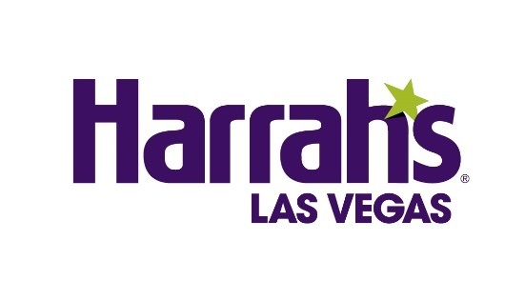
DONNY OSMOND RETURNS TO THE LAS VEGAS STAGE WITH
FIRST-EVER SOLO RESIDENCY AT HARRAH’S LAS VEGAS

Tickets go on sale starting Tuesday, Nov. 24, 2020
Shows begin Tuesday, Aug. 31, 2021

**For high-res photos and admat, click here**

LAS VEGAS (Nov. 20, 2020) – Legendary entertainer and music icon, Donny Osmond, today announced his return to Las Vegas and the Caesars Entertainment family with his first-ever solo multi-year residency inside Harrah’s Showroom at Harrah’s Las Vegas, opening Tuesday, Aug. 31, 2021.

“Donny Osmond has achieved a lifetime of remarkable milestones as an entertainer, including countless memories with us during his 11-year run at Flamingo,” said Caesars Entertainment Regional President Gary Selesner. “We’re thrilled to welcome him to the stage at Harrah’s Las Vegas next summer for an all-new show, and we look forward to sharing many more unforgettable moments with our guests and one of music’s most beloved stars.”

In an unprecedented and history-making deal for Harrah’s, Osmond’s return to stage will be an exciting, energy-filled musical journey of his unparalleled life as one of the most recognized entertainers in the world. Guests can expect a party as he performs his timeless hits, shares stories of his greatest showstopping memories and introduces brand new music in a completely reimagined song and dance celebration. The announcement comes almost exactly one year after the curtains closed for the final time on his previous record-breaking 11-year residency at Flamingo Las Vegas. Fans can once again experience an unforgettable night with Donny Osmond – exclusively at Harrah’s Las Vegas.

Spanning five decades of entertainment, Donny Osmond has been a singer, actor, triple-threat television series host (talk show, game show, variety show) and best-selling author (his autobiography entered the UK bestseller chart at #1). Throughout his illustrious career, Donny has earned 33 gold records; selling over 100 million albums becoming a worldwide music legend. Currently Donny is hard at work on his 63rd album which is set to be all original music for the performer. Osmond’s debut at Harrah’s signifies the launch of his highly anticipated world tour.

“Las Vegas has been great to me and my family and in many ways, so this feels like a homecoming,” said Osmond. “I am incredibly excited to return to the entertainment capital of the world for my own solo residency at Harrah’s Las Vegas next summer, and I hope my fans are as excited as I am.”

“The addition of the renowned talent of Donny Osmond to our already impressive entertainment lineup further cements Harrah’s position as a leading center-Strip property,” added Dan Walsh, Senior Vice President and General Manager of Harrah’s Las Vegas.

Tickets will go on sale to the public starting Tuesday, Nov. 24 at 10 a.m. PT. Presale tickets for Caesars Rewards members as well as Ticketmaster customers will be available Monday, Nov. 23 from 10 a.m. to 10 p.m. PT.

General ticket prices begin at $65, plus applicable tax and fees. Also, a limited number of VIP meet & greet packages are also available for performances Tuesdays through Fridays only. All tickets and packages can be purchased online at www.ticketmaster.com/donny. Performances will take place nightly from Tuesday to Saturday with all shows beginning at 8 p.m.

The available performances going on sale are:

August 2021: 31
September 2021: 1 – 4, 7 – 11, 14 – 18, 28 – 30
October 2021: 1 – 2, 5 – 9, 12 – 16
November 2021: 2 – 6, 9 – 13, 16 – 20

About Harrah’s Las Vegas
With more than 2,500 hotel rooms and suites, Harrah’s Las Vegas is an affordable, welcoming resort where guests can break away from their daily routine in a playful atmosphere. The newly renovated Valley Tower features 1,600 stylish rooms with warm tones of gray and purple accents, as well as dark wood furnishings. Harrah’s Las Vegas features 87,000 square feet of casino space, a modern Race & Sports Book offering both live gaming and sports betting, and more than 25,000 square-feet of meeting and convention space. Six restaurants encompass everything from Toby Keith’s ‘I Love This Bar & Grill,’ which offers an all-American menu and live music nightly, to the chef-driven Fulton Street Food Hall, to the upscale setting of Ruth’s Chris Steak House, a romantic venue with breathtaking views of the Strip. Harrah’s outdoor bar, Carnaval Court, brings high energy to the Las Vegas Strip with live music and some of the world’s top flair bartenders who juggle and pour to perfection. A wide variety of entertainment options include Donny Osmond, magician Tape Face and adult revue X Country. Harrah’s Las Vegas is operated by a subsidiary of Caesars Entertainment, Inc. (NASDAQ: CZR). For more information, please visit harrahslasvegas.com or the Caesars Entertainment Las Vegas media room. Find Harrah’s Las Vegas on Facebook and follow on Twitter and Instagram.

Media Contacts:
Harrah’s Las Vegas
Robert Jarrett
RJarrett@caesars.com

Donny Osmond
Susan Madore
susan@guttmanpr.com

