THE NATURE OF GOD
1 WE believe in God, the Eternal Father, and in His Son, Jesus Christ, and in the Holy Ghost
(Pearl of Great Price | Articles of Faith 1:1)

There are Christian professors who claim that members of The Church of Jesus Christ of Latter-day Saints are not Christion because we do not accept in the traditional belief concerning God, the Father and his Son, Jesus Christ and in the Holy Ghost as being “one in substance” as taught in the Nicene and other creeds.
It is strange to me that there could be any confusion about our devotion to Jesus Christ, given the official name of our church: The Church of Jesus Christ of Latter-day Saints. However, we do not accept the common doctrine that God the Father and his Son, Jesus Christ and the Holy Ghost are all one substance, one God that is manifest in these different roles as some explain it.
To me the scriptures are so very clear on this important subject as the Lord emphasized:
3 And this is life eternal, that they might know thee the only true God, and Jesus Christ, whom thou hast sent.
(New Testament | John 17:3)

I believe Adam and Eve, our first parents, were created by our Heavenly Father and Jesus Christ together in their image and likeness:
26 ¶ And God said, Let us make man in our image, after our likeness: and let them have dominion over the fish of the sea, and over the fowl of the air, and over the cattle, and over all the earth, and over every creeping thing that creepeth upon the earth.
27 So God created man in his own image, in the image of God created he him; male and female created he them. (Genesis 1:26 - 27)

I have seen that Christian professors quote the following , when Jesus’ disciples ask him to show them the Father and he answered: …he that hath seen me hath seen the Father; and how sayest thou then, Shew us the Father? (John 14:9) They appear to interpret this passage to support the belief that the Father and the Son are the same substance, but much of the New Testament speaks of the Son praying to the Father and in other ways identifying them as separate individuals. I counted 16 times in just the book of Matthew that Jesus refers to God as “My Father”,
The following passage helps us understand the verse above as it makes it clear what Jesus meant when he said “he that hath seen me hath seen the Father”:
1 GOD, who at sundry times and in divers manners spake in time past unto the fathers by the prophets, 2 Hath in these last days spoken unto us by his Son, whom he hath appointed heir of all things, by whom also he made the worlds; 3 Who being the brightness of his glory, and the express image of his person, when he had by himself purged our sins, sat down on the right hand of the Majesty on high; (Hebrews 1:1 - 3)
It also makes it clear that Jesus and God are separate beings and that God has a body, with a right hand.
The testimony of Stephen as he was being stoned also clarifies the nature and being of God:
55 But he, being full of the Holy Ghost, looked up stedfastly into heaven, and saw the glory of God, and Jesus standing on the right hand of God, 56 And said, Behold, I see the heavens opened, and the Son of man standing on the right hand of God. (Acts 7:55 - 56)
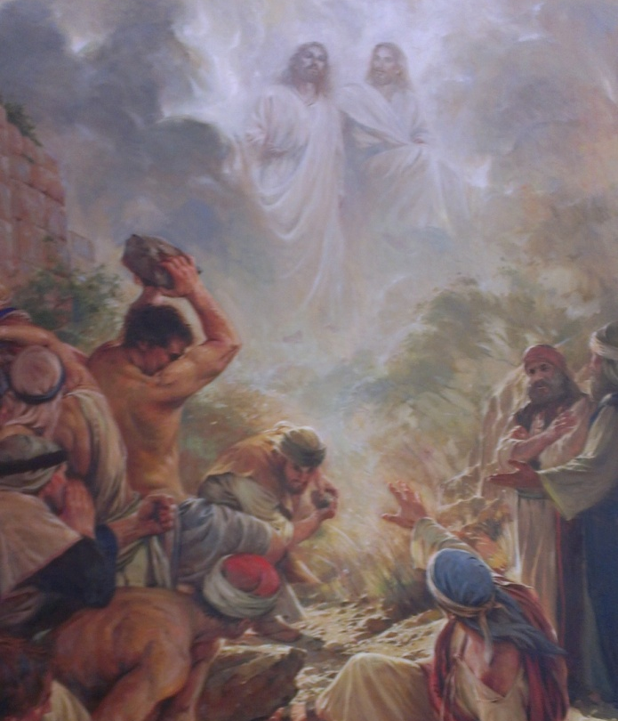
Many believe that God and Christ are the same personage who has manifest himself in different times as the Father, the Son “of one substance” as is represented in the Nicene Creed http://en.wikipedia.org/wiki/English_versions_of_the_Nicene_Creed_in_current_use .
There are passages that would indicate as much, such as John 10:30: I and my Father are one. I believe, however, that the true interpretation of this scripture is made easy by the Lord’s petition where he pleads with the Father that all of his followers will be one as he and the Father are one:
11 Holy Father, keep through thine own name those whom thou hast given me, that they may be one, as we are… Neither pray I for these alone, but for them also which shall believe on me through their word; That they all may be one; as thou, Father, art in me, and I in thee, that they also may be one in us: that the world may believe that thou hast sent me. (John 17:11, 20- 21)
Another very powerful scriptural passage on this subject is the response of Jesus when he first met Mary Magdalene near his tomb the morning of the resurrection:
17 Jesus saith unto her, Touch me not; for I am not yet ascended to my Father: but go to my brethren, and say unto them, I ascend unto my Father, and your Father; and to my God, and your God. (John 20:17)

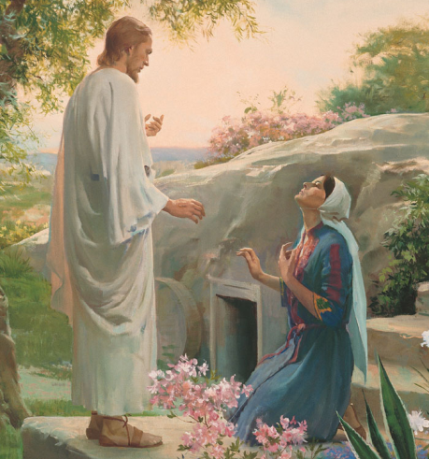

I believe it is clear in the Scriptures that God the Father is a perfect and divine immortal and glorified personage in whose image and likeness Jesus and we are. I believe it is very clear that Jesus Christ is the only begotten Son of God, separate and distinct personages with one unified purpose.
God is the Father of our spirits:
The scriptures teach that …we are the offspring of God…(Acts 17:29) as spirits in a pre-mortal life, where we learned and progressed and even made choices that impacted our lives on this earth. Some had no faith in the plan of the atonement of Christ and chose to follow Satan and rebel. There was a war in heaven and Satan and his followers were overcome and cast out to the earth where they continue to tempt and deceive mankind away from following Christ:
7 And there was war in heaven: Michael and his angels fought against the dragon; and the dragon fought and his angels, 8 And prevailed not; neither was their place found any more in heaven. 9 And the great dragon was cast out, that old serpent, called the Devil, and Satan, which deceiveth the whole world: he was cast out into the earth, and his angels were cast out with him. (Revelation 12:7 - 9)
I believe the angels who fought with Michael included those of us who have born into mortality. We obviously had enough faith to be willing to be born and to prove ourselves in a mortal state, face mortal death with the hope of a resurrection. The war in Heaven, I believe was a war of words and testimony concerning the pending atoning sacrifice of Jesus Christ:
11 And they overcame him by the blood of the Lamb, and by the word of their testimony; and they loved not their lives unto the death. (Revelation 12: 11)
To me, the scriptures are clear on our relationship with our Heavenly Father:
16 The Spirit itself beareth witness with our spirit, that we are the children of God: And if children, then heirs; heirs of God, and joint-heirs with Christ; if so be that we suffer with him, that we may be also glorified together. (Romans 8:16 - 17)
9 Furthermore we have had fathers of our flesh which corrected us, and we gave them reverence: shall we not much rather be in subjection unto the Father of spirits, and live? (Hebrews 12:9)
These passages help us know who we are and where we came from. They tell us that we were born as a spirit sons and daughters of a Heavenly Father who loves us and who has a plan for us to inherit a place in his kingdom.
Another confirming passage is the Lord’s question to Job
4 Where wast thou when I laid the foundations of the earth? declare, if thou hast understanding.
5 Who hath laid the measures thereof, if thou knowest? or who hath stretched the line upon it?
6 Whereupon are the foundations thereof fastened? or who laid the corner stone thereof;
7 When the morning stars sang together, and all the sons of God shouted for joy? (Job 38:4 – 7)
The Poet Wordsworth wrote: “We do not suddenly flare into existence, but with trailing clouds of glory, do we come from God, who is our Home”.
Knowing that we are “offspring of God” (Acts 17:29) gives added meaning to the passage:
3 And this is life eternal, that they might know thee the only true God, and Jesus Christ, whom thou hast sent. (John 17:3).
I believe that “life eternal” means life forever in the presence of our Father in Heaven and that knowing him clarifies our divine purpose, which is if we “suffer with him” or “be in subjection” to him we can inherit his kingdom as “heirs of God, and joint-heirs with Christ… whom he hath appointed heir of all things (Hebrews 1:2)
21 To him that overcometh will I grant to sit with me in my throne, even as I also overcame, and am set down with my Father in his throne. (Revelation 3:21)
Some say that for us to claim to be in the image of God and that we have faith that by following Christ we can become his heirs, joint heirs with Christ who is heir of all things, and to become like him, belittles or lessons the divinity of an unfathomable God, but I believe that God is not unfathomable. Though he is all-knowing, all-powerful and his influence is everywhere present, he is yet a loving Father and wants us to have all that he has. This will include a resurrected, immortal and celestial, glorified body (see 1 Corinthians 15: 40-42) and eventually a perfected nature:
48 Be ye therefore perfect, even as your Father which is in heaven is perfect. (Matthew 5:48)
There will be more written on this as it relates to the Temples following.

